

**April 14, 2025**

YouTube Deluxe **System Requirements Document**

By: Froggert’s Friends:

**Martin Mcgill,**

**Heidi Scherer-Blake,**

**and Jack Davis**

**TABLE OF CONTENTS**

**Introduction… pg 3**

**Description Model … pg 3 - 5**

**Class Diagram…**

**Use Case Diagram …**

**Use Case Scenarios…**

**System Sequence Chart…**

**INTRODUCTION (MM)**This document will show how YouTube Deluxe and its functions work together to provide a better experience for the user. The document will go more into detail on 1 hour free listening, guitar/chords, Dislike button, social ranks and YouTube Wrapped. This document will explore functionality of user and system interactions. This document will allow for a safe integration and documentation of what is going to be in the app.

**Description Model (MM)**

**1. Button:** Bringing Back The dislike button after it was taken in 2021

* Users will be able to see how much dislikes are on a video
* Users can also dislike the video
* The creator can either show the dislikes or remove them

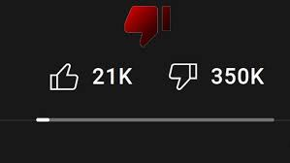

**2. Guitar Chords/Tabs :**

* Creators of the video can make tabs for the video to show or have ai do it for them
* There will be an arrow on the top right of the music video to have the pane of the chords and tabs to pop out.
* Tabs will have frets and which finger to use and chords will show formation and which fingers to use on each

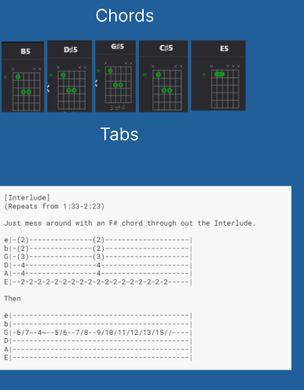

**3, Channel Rankings:**

* Will show when channel was made
* How much viewers they get yearly/monthly
* Can view previous years
* Can also where these channels get ranked against other creators

**4. Youtube Wrapped(MM):**

* Instead of only having Youtube music wrapped user can have their own custom Youtube Wrapped
  + - - This will include users most watched channel and how many hours they spent watching them
    - - How much time the user spent watching Youtube
    - - Users most watched video with hours and minutes spent
    - - Total watch time and the day the user spend the most watching Youtube
    - - A list of User top 5 content creators

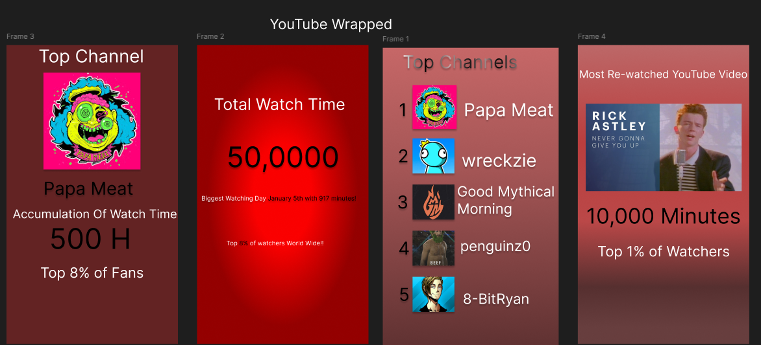

**5. Ad-free listening(HS):**

* Click on popup to watch 60 second ad for 30 minutes of ad free watching
* The 60 second ad of the users choice to watch and they will not be forced to watch this kind of ad.
* Ad free listening will stay consistent through each video the user 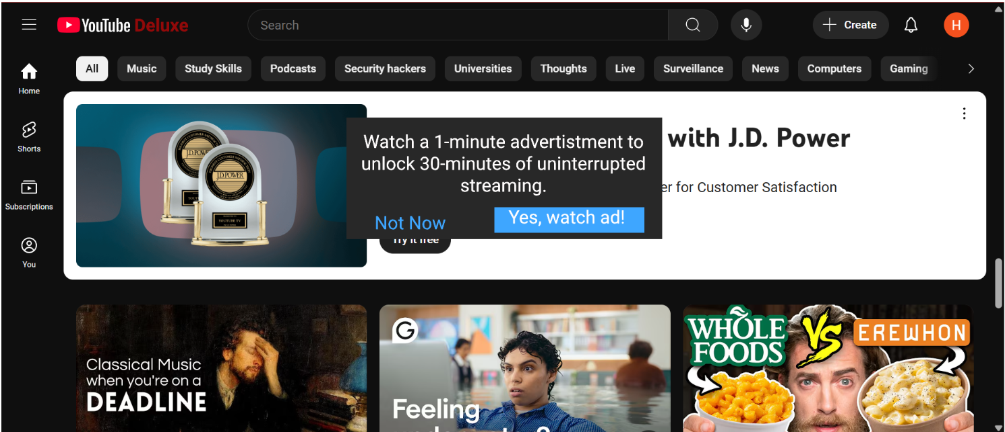watches